* [**How to add a Site Column to a SharePoint list**](https://sharepoint.rackspace.com/Learning/Articles/Pages/SharePoint-2013--how-to-add-a-site-column-to-a-SharePoint-list.aspx)

In this tutorial I will cover adding the “Product Offering” Site Column, created in a different tutorial called [**How to create a Site Column**](https://sharepoint.rackspace.com/Learning/Articles/Pages/SharePoint-2013--how-to-create-a-site-column.aspx), to a SharePoint Custom List.  If you haven’t watched [**How to create a Site Column**](https://sharepoint.rackspace.com/Learning/Articles/Pages/SharePoint-2013--how-to-create-a-site-column.aspx), check it out. 

1. From your SharePoint site open any Custom List you would like, in this example I will open my “**SharePoint Training**” list.

2. At the top of the page click **LIST** to expand the ribbon.

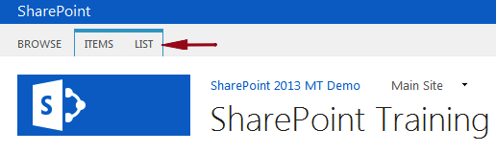

3. In the Settings section click **List Settings**.

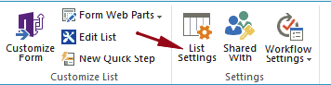

4. On the Settings page under Columns click **Add from existing site columns**.

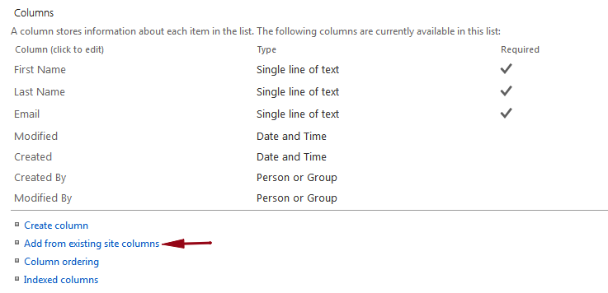

5. On the Add Columns from Site Columns page under Select site columns from: click the drop-down arrow and click **Custom Columns**.

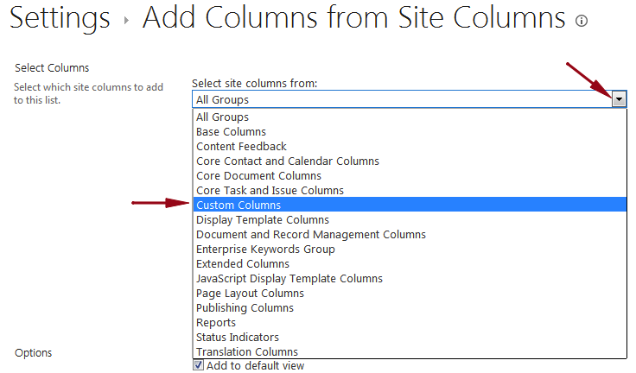

In [**How to create a Site Column**](https://sharepoint.rackspace.com/Learning/Articles/Pages/SharePoint-2013--how-to-create-a-site-column.aspx) this is the group where I created the site column, if you created your site column in a different group you can select that now. Alternatively, you could just scroll through the list until you come across your site column, I prefer to select my group first as this makes it easier to find.

6. Under Available site columns: click **Product Offering**.

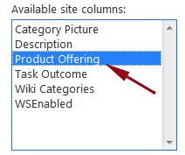

7. Click **Add**.

8. The Product Offering site column will now be under the Columns to add: section.

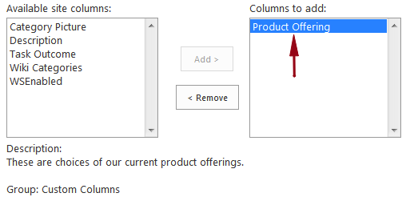

9. Review your settings and click **OK**.

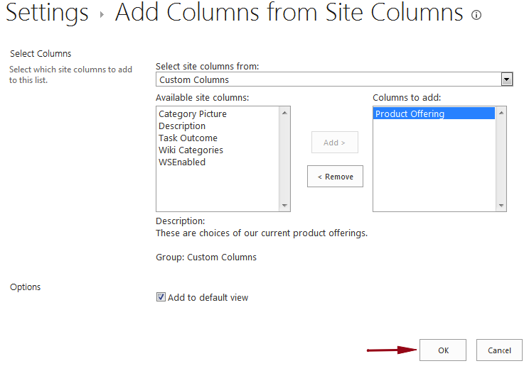

10.  Back on the Settings page under Columns you will see the Product Offering site column.

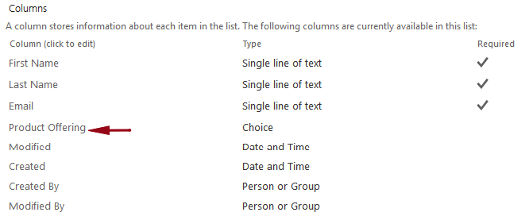

11. Go back to your SharePoint List (in this example “SharePoint Training”) and edit any of your items.

12. In this example, I will edit User1 and select **Beginner SharePoint 2013 Training** from the Product Offering drop-down.

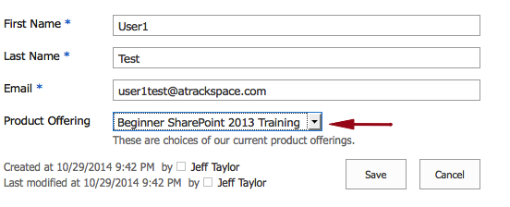

13. Click **Save**.

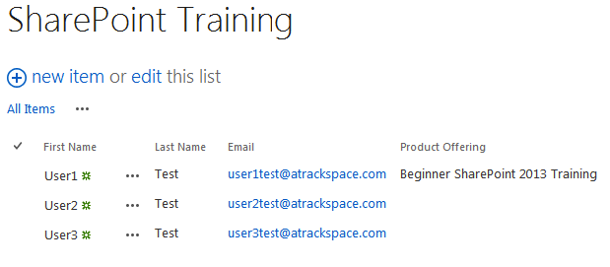

Not quite as simple as adding a normal SharePoint column but remember the great thing about a site column is it can be reused in my subsites. This will cut down on the amount of work you have to do and maintain consistency throughout your list and libraries.

​